*Session:*

To manage application state, we use session during post back.

*Create Session:*

*Step 1*:

Install session package as showing in screenshot.

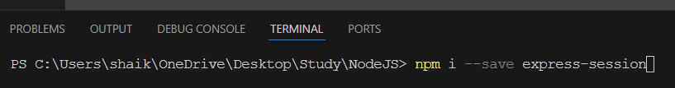

*Step 2:*

Before using session, we need to import session package in app.js file & using middle ware add this imported session as shown below.





Create & Read Session value:

